**COLLEGE WEBSITE**

**MINI PROJECT REPORT**

**BACHELOR OF TECHNOLOGY**

Computer Science and Engineering

**SUBMITTED BY**

Mohammed Bilal (2105050100032)

Syed Taha Ahmad (2105050100053)

Omer Ahmad Sayed (2105050100038)

2022-23



**UNDER THE SUPERVISION OF**

Ms. Renu Chaurasia

**DEPARTMENT OF COMPUTER SCIENCE & ENGINEERING**

**ALLENHOUSE INSTITUTE OF TECHNOLOGY KANPUR**

**ABSTRACT**

A Clock is an mechanical or electrical device for measuring time, indicating hours, minutes, and

sometimes seconds by hands on a round dial or by displayed figures. In our project we use the <graphics.h>file which we need to install it through libgraph or by any other external means . C graphics using graphics.h functions or WinBGIM (Windows 7) can be used to draw different shapes, display text in different fonts, change colors and many more. Using functions of graphics.h in Turbo C compiler you can make graphics programs, animations, projects, and games. We directly link the analog clock with the computers clock system. So the analog clock which is displayed on output screen will display the same time as in the computer system.

**CERTIFICATE**

This is to certify that the project report(KCS354) entitled **“ANALOG CLOCK USING GRAPHICS”** done by **Mohamed Bilal (2105050100032) ,Syed Taha Ahmad (2105050100053) , Omer Ahmad Sayed(2105050100038),** is an authentic work carried out by them at **Allen house Institute of Technology** under the guidance **of Ms. Renu Chourasia** matter embodied in this project work has not been submitted earlier for the award of any degree or diploma to the best of my knowledge and belief. Certified that this is a bonafide record of the project work titled.

**Ms. Renu Chaurasia Dr. Sudhir Kr Singh**

Project Guide Head of Department

**TABLE OF CONTENT**

1. Introduction of Project 5
2. Objective 6
3. Hardware & Software Specification 7
4. Design 8
5. Coding 9-11
6. Screenshots 12
7. Conclusion and Future Scope 13
8. Bibliography 14

**INTRODUCTION OF PROJECT**

A Clock is an mechanical or electrical device for measuring time, indicating hours, minutes, and sometimes seconds by hands on a round dial or by displayed figures. According to scientific definition, its an instrument other than a watch for measuring or indicating time, especially a mechanical or electronic device having a numbered dial and moving hands or a digital which occurs with the passage of time, as in a computer. In our project we make an analog clock in C++ using <graphic.h> header file. C graphics using graphics.h functions or WinBGIM (Windows 7) can be used to draw different shapes, display text in different fonts, change colors and many more. Using functions of graphics.h in Turbo C compiler you can make graphics programs, animations, projects, and games. Although we need to separately install the <graphic.h> file using libgraph.

**OBJECTIVE**

A Clock is a device which is used to display time which indicate the hours, minutes and seconds by hands on a round dial by hands or by other display figures. We create this analog clock on C++ platform using the <graphic.h> file which is a header file in C++ used for making graphics programs, animations, projects, and game. The main objective is to understand the use of graphics in C and header file <graphic.h> and to implement it in animation and graphical field.

**HARDWARE AND SOFTWARE SPECIFICATION**

**Hardware Requirements**

1. Intel core i5 10th generation is used as a processor because it is fast than other processors and provide reliability and stability.
2. Ram 8GB is used as it will provide fast reading and writing capabilities and will in turn support in processing.

**Software Requirements**

1. **Operating system-** Windows 11 is used as the operating system as it is reliable and supports more features and is more user friendly.
2. **Development tools and Programming languages-** Dev C++is a platform which we used to code the following program and we download the <graphic.h> header file externally by libgraph or by other external platforms.

**Technology used in Project:**

The whole project is created on the Dev C++ platform using <graphic.h> header file downloaded by libgraph or any external means.

**DESIGN**

**Module Description**

There are essentially two modules of this software:

**Admin module**: The Clock is directly integrated with the system. Hence the output depends upon the time till the program runs which is directly dependent upon the admin which is the one running the program.

**Normal Users:** The normal users gets the functionality of getting the time till the program is being runed by admin in the computer system or the device attached to the program .The functionality terminates once the program stops and the user gets the desired output.

**CODING**

**C++:**

**#include<iostream>**

**using namespace std;**

**#include<graphics.h>**

**#include<math.h>**

**#include<string.h>**

**#include<time.h>**

**#define PI 3.14**

**int main()**

**{**

**initwindow(1600,1600,"Analog Clock");**

**int page=0;**

**while(1)**

**{**

**setactivepage(page);**

**setvisualpage(1-page);**

**circle(250,250,200);**

**circle(250,250,5);**

**outtextxy(250+180*sin(PI/6),250-180*cos(PI/6),"1");**

**outtextxy(250+180*sin(2*PI/6)-5,250-180*cos(2*PI/6),"2");**

**outtextxy(250+180*sin(3*PI/6)-5,250-180*cos(3*PI/6),"3");**

**outtextxy(250+180*sin(4*PI/6)-5,250-180*cos(4*PI/6),"4");**

**outtextxy(250+180*sin(5*PI/6)-5,250-180*cos(5*PI/6),"5");**

**outtextxy(250+180*sin(6*PI/6)-5,250-180*cos(6*PI/6),"6");**

**outtextxy(250+180*sin(7*PI/6)-5,250-180*cos(7*PI/6),"7");**

**outtextxy(250+180*sin(8*PI/6)-5,250-180*cos(8*PI/6),"8");**

**outtextxy(250+180*sin(9*PI/6)-5,250-180*cos(9*PI/6),"9");**

**outtextxy(250+180*sin(10*PI/6)-5,250-180*cos(10*PI/6),"10");**

**outtextxy(250+180*sin(11*PI/6)-5,250-180*cos(11*PI/6),"11");**

**outtextxy(250+180*sin(12*PI/6)-5,250-180*cos(12*PI/6),"12");**

**time_t now=time(0);**

**tm *ltm=localtime(&now);**

**system("cls");**

**cout<<ltm->tm_hour<<" "<<ltm->tm_min;**

**setcolor(RED);**

**line(250,250,250+150*sin(ltm->tm_hour*PI/6),250-150*cos(ltm->tm_hour*PI/6));**

**setcolor(GREEN);**

**line(250,250,250+190*sin(ltm->tm_min*PI/30),250-190*cos(ltm->tm_min*PI/30));**

**setcolor(WHITE);**

**line(250,250,250+150*sin(ltm->tm_sec*PI/30),250-150*cos(ltm->tm_sec*PI/30));**

**if(GetAsyncKeyState(VK_RETURN))**

**break;**

**delay(10);**

**page=1-page;**

**}**

**getch();**

**return 0;**

**}**

**SCREENSHOTS**

OUTPUT SCREEN:

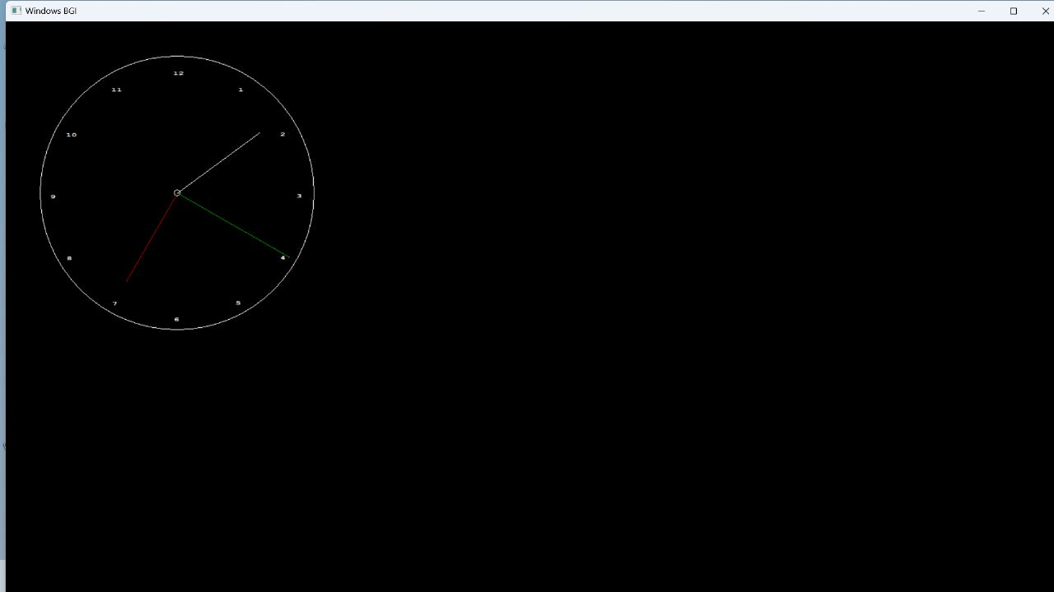

**CONCLUSION**

The Output screen displays the analog clock which was created using graphics header file. The output clock is directly integrated with the system clock .So the output screen displays the time which is displayed in the system. The times keeps on getting displayed till the program is running. Once the program is stopped, the time getting displayed is terminated. Once we run the program again, the current time of the system during runtime will be displayed.

**BIBLIOGRAPHY**

1. <https://en.wikipedia.org/>.
2. <https://www.youtube.com/>
3. <https://www.google.com/>